In attendance: Bud Murphy, Dianne Ackerman, Tim McChesney, Jennifer McManus (Student Representative), Steve Andrew (Borough Council) & Bruce DiBisceglie (dept chair). Meeting Location: Garabrant Center

- Communications
  - February 2019 Mendham Borough Recreation Committee (MBRC) meeting minutes were approved.
    - Minutes and agendas will be posted to the Mendham Borough website as approved.

  - Communications:
    - On February 26th, Bruce receive an email from three Mendham HS students (Dylan Byrne, Matt Kornick & Matt Cantale) about a proposal to build a Gaga Pit at Borough Park for their HS Service Learning Project.
    - On March 5th, Bruce received an email from Fran Plodkowski (Mendham Business Association) to share that the members of the MBA would like to submit their businesses as part of the Mendham Borough Recreation’s 2nd Annual Holiday Home Decorating Contest in Dec 2019.
    - Bruce received 106 requests for employment for the 2019 summer Day Camp.
    - Bruce reported that Eric Inglis will send the final contract to the contractors by March 22, then their contractor will advise when the Field Turf will be installed. Tim shared that the installation process is quick and the Mutli-Use Turf field should be available to the public this Spring.
    - On March 10th, a Field Request was received from St Joseph’s school for June 7th at West Field from 6-10am.
    - Bruce received unsolicited requests from various musical acts wishing to play at the Mendham Borough Summer Concert Series.

  - Meetings:
    - On February 15th Bruce attended a meeting with Mayor Glassner, Borough Administrator Joyce Bushman and Township Administrator Deborah Bonanno to discuss sharing of Recreational services between the two municipalities.
      - The possibility of the Borough sharing the services of Bruce with the Township was discussed for certain areas. Details to be determined
      - Deborah reported that David Guida is filling the position of Recreation Director for the Township on a temporary basis. The position was vacated by Steve Eisenstein who has taken the position of Assistant Director of Parks & Recreation in Randolph. David is also Sponsorships and Program Coordinator for the City of Summit.
      - Bruce and David have been working together prior to this meeting to update the “The Mendhams 2019” booklet.
      - David will be overseeing the following programs which are available to both the Borough and Township
        - the Mendham Ski Program trips
        - the Patriots Path race
        - the “Teen Adventures” travel camp to Dorney Park, Hershey Park, Great Adventure, Hurricane Harbor, Waterworks, I-Play America, Dave & Busters and more.
        - Brookside Beach
      - Deborah reported that field scheduling and maintenance may be a challenge, and this could be the first place where Bruce can help as the Borough’s scheduling is online and streamlined.
    - Bruce & Steve attended the Meeting of the Mayor and Borough Council on February 25th
      - Resolution 58-2019 was proposed that grants Borough-Sponsored Events Tier One Priority for the Mendham Banner on East Main Street. Bruce will inquire whether this can be applied to the Food Truck Festival, as the FTF banner request was originally rejected since the lead-up time to the FTF on June 15th was already booked.
      - Steve reported and Bruce concurred that
        - the 2019 Field Allotment was completed and posted to the Borough website
        - “The Mendhams 2019” annual recreational booklet and municipal guide will be mailed out to all Borough residents by the target date of April 1st
        - Bruce confirmed with JMK Events that the Food Truck & Music Festival is set for June 15, 2019 at Borough Park. The Borough will need to do significant promotion to increase attendance over 2018 figures (~3000)
      - All Bands and Movies have been contracted by Bruce with the vendors
    - Steve attended the Meeting of the Mayor and Borough Council on March 13th
      - Steve reported that John & Penny Andrus have been added to the list of future Grand Marshals to be nominated by future Borough Councils.
      - Steve requested updates on improvements for the Borough Park playground area. .

- 2019 Food Truck & Music Festival:
  - Melissa Wojcik will be the point-person for promotion of the FT&MF. Promotion will include, but not be limited to:
    - Posters for local business (similar to old-style carnival posters)
    - Promotion in “The Mendhams 2019” annual booklet (already included on page 24 and the full inside back cover)
    - Possible postcard mailers
    - School distribution.
  - Bruce has spoken to David Guida about cross-promoting the FT&MF with the Township’s 117th Annual Patriots’ 5K Race & Fun Run which is to be held on the same day, Saturday June 15th at 9am. The hope is to offer a pay-one-price admission to the 5K at 9am which would be accepted at the FT&MF between 11am-7pm later in the day.
  - As in 2018, JMK will be responsible for all permits, labor, vendors and logistics. JMK is requesting heavy promotion by the Borough.

- Day Camp Updates:
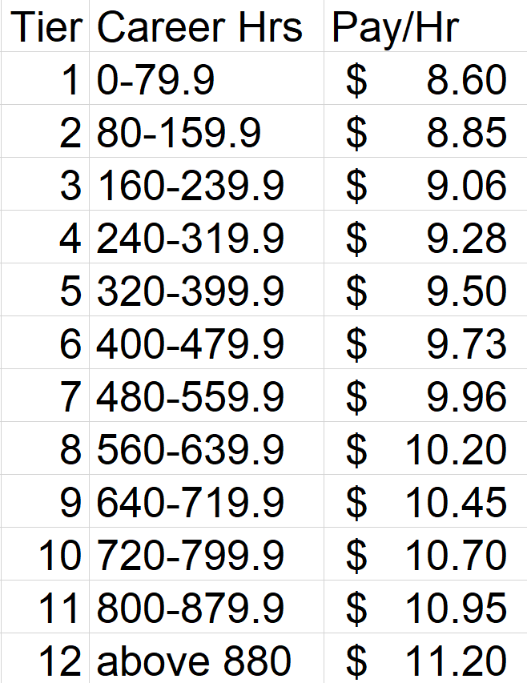
  - Bruce received 106 applications for employment by the February 28th deadline. Of the 106, 56 are first time applicants and all will be interviewed by Bruce between March 19 and April 11.
  - The Committee inquired about how the process of Working Papers and Registration will be handled without Penny Andrus. Bruce will fill the void and Karen Orgera will process incoming mail and requests for Bruce and direct all requests to Bruce.
  - A new pay scale is being introduced for the Counselors. The scale is based on a tiered system recognizing total career hours worked at the Day Camp. Senior Staff (Directors and Head Counselors are not on the Tiered Scale and their pay is set from year to year with no annual increases built in.
  - Directors have already been hired (all had the same positions in 2018)
    - Camp Director Amanda Sherwin
    - Asst Camp Director Kristel Gallagher
    - Medical Director Kyle Wiggins
    - Art Director Julia Drahzal
  - Bruce is in the process of hiring Head Counselors (Jennifer McManus accepted position at the meeting). Two 2018 Head Counselors are returning (including Jennifer) and there are 15 applicants requesting Head Counselor employment to fill the remaining three Head Counselor positions. Several will be hired as Head Counselors in Training (at a wage that averages their regular salary and the Head Counselor salary of $13/hr.
  - Bruce estimates that about 70 total employees will be hired from the pool of 106. Number depending on camper registration totals.
  - Bruce also reported that he has followed up with Jeff Carter, the new owner of “The Club at Mendham” (aka: The Mendham Tennis and Racquet Club). Bruce spoke with manager Brian Manning and both agreed that there should not be a problem with the Day Camp attendance for the five Fridays (June 28, July 5, 12, 19 & 26) at the Club’s pool.

- Prior Business:
  - Labor Day Parade
    - The MBRC discussed possibilities for the 2019 Labor Day Parade Theme. The MBRC felt that the theme should honor the Garden Club and Dotty Fleming. Of the several suggestions, the Committee unanimously decide upon the 2019 Labor Day Parade Theme of “Growing the Spirit of Mendham”. This theme will be communicated to all parade participants to guide them with their float and display ideas.
    - Bruce will immediately coordinate with Jeff Cooper/DPW about the installation of the new Walk of Fame commemorative bricks leading from Mountain Ave to the Gazebo. The initial outlay will be for thirty-three 4”x8” finished bricks honoring the past Grand Marshals. Each brick with have the name of the Grand Marshal(s) and the year they served Bricks will be ordered from bricksus.com at a cost of $19/brick. The color scheme will be “antique red” and will be order by Bruce. Target date for installation will be any time prior to the Labor Day Parade.
  - Booklet Updates:
    - Bruce has ordered the mailing labels from Vital Inc. and provided the labels, along with a postal check for $462.53 to Hawk Graphics. The Booklets will be mailed on Friday, March 15th, sixteen days ahead of schedule. The booklets are expected to hit resident mailboxes by Wednesday March 20th.
    - Bruce will contact the Mendham Business Association to distribute complementary booklets to Mendham businesses and local realtors (Realtors in the past have reported that the booklets are a good tool to provide to prospective Mendham home-buyers).
    - The cost of the booklets was $3,355. As the Borough mails hardcopies to residents while the Township makes the .pdf available online only, the Borough will pay 100% of the hardcopy processing ($2,255) and the mailing ($500). The Township will only split the typesetting costs evenly with the Borough ($300 each). The Borough has paid the full Invoice from Hawk Graphics and the Township will reimburse the Borough for $300. Requests from non-Borough residents for hardcopies of the Booklet will be processed at the Bowers Building and charged $2 each.
  - Middle School activities
    - At the February MBRC meeting, Dianne requested information for summer activities for 7th & 8th graders as this group has aged out as campers at the Day Camp, but are too young to be employed as Counselors at the Camp.
    - Bruce looked into it and suggested the “Teen Adventure Travel Camps”. These camps are available to Borough & Township residents from 7th through 10th grade (as of Sept ’19) and that registration is done through the Township’s offices. (see 1,C.i.4 above)
  - Borough Park Playground updates
    - Bruce replied to Steve’s request (see 1,C,iii,2 above) that Bruce & Jeff had earmarked three projects for the Playground (replace swing set, replenish sand base and install a rock climb).
    - Cost for the new swing set when identified by Jeff Cooper in 2018 was a range from $950 to $1100. The RockScape would cost approximately $5000.
    - The MBRC felt that the swing set and sand should be the immediate priority while the rock wall was not consistent with the age group that attends the playground. Bruce will follow up with Jeff.
    - Steve also reported that the proposed tennis wall was not approved by the Borough Council.

- New Business:
  - Steve added John & Penny Andrus to the list of future potential Grand Marshals.
  - Field request for St Joseph’s Field Day on June 7th at West Field 6-10 am was approved & processed by Bruce.

Next Meeting: 7:30pm, Thursday, April 11, 2019 at the Garabrant Center

